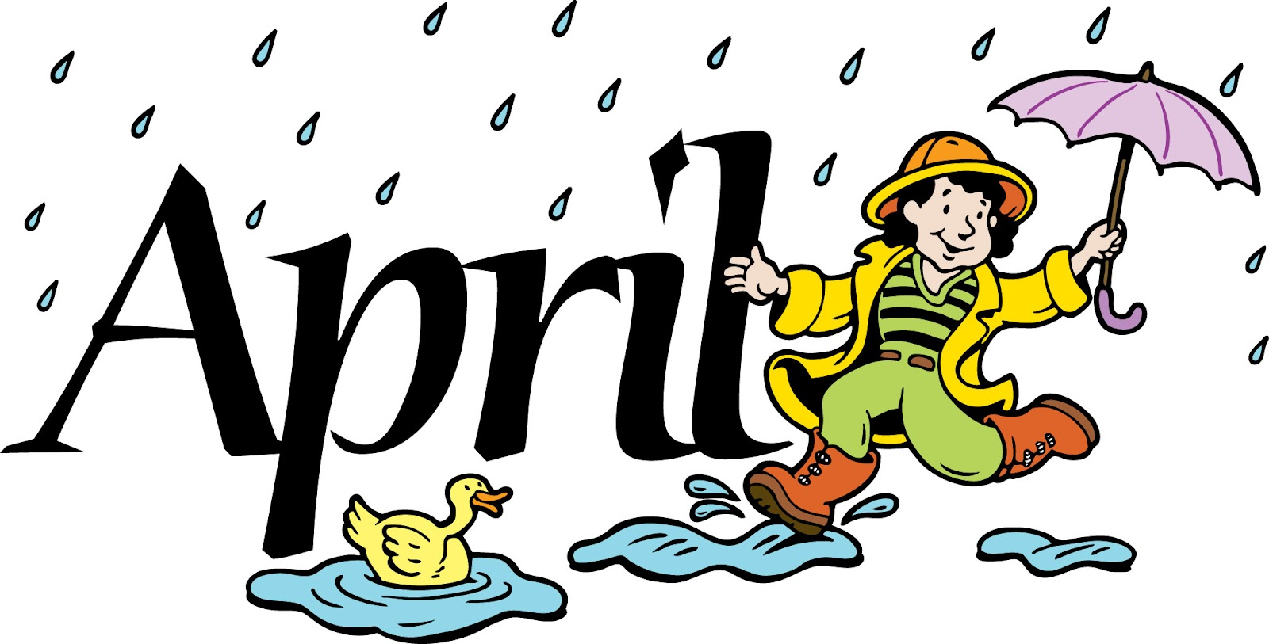

BECKEMEYER SCHOOL
APRIL Newsletter

SCHOOL RESUMES/ Early Dismissal
School will resume on Monday, April 1st. School will dismiss early on Wednesday, April 24th at 11:25.

IAR TESTING
All 3rd, 4th, & 5th grade students will take the Illinois Assessment of Readiness(IAR) test beginning Monday, April 8th. This is our annual state testing that takes about a week to complete. Please make sure your child is well rested and on time to school during testing.

BECKEMEYER NIGHT AT MCDONALD’S
We have a Beckemeyer night at McDonald’s on Tuesday, April 16th.

Cell Phones, Electronic Gadgets, and Toys
All items of this type must be left at home.

STUDENT DRESS
Please make certain that children dress appropriately for school – a task that is becoming more difficult with today’s fashions. Shirts and blouses must cover the shoulders, shorts should be of adequate length, and clothing should meet in the middle (midriffs must be covered).

Dismissal Changes
Please call the office before 2:00 with any changes.

